**Online Test Application**

**1 Description:**

This **Online Test Application** system secure, professional web-based questionnaire Easy to use, for business, training, and educational assessment with instant score

tests and quizzes saving you hours of paperwork.This project was generated with [Angular CLI](https://github.com/angular/angular-cli) version 11.2.5.

**The project is developed by:** Sunny Mishra

1. **Project Layout**:

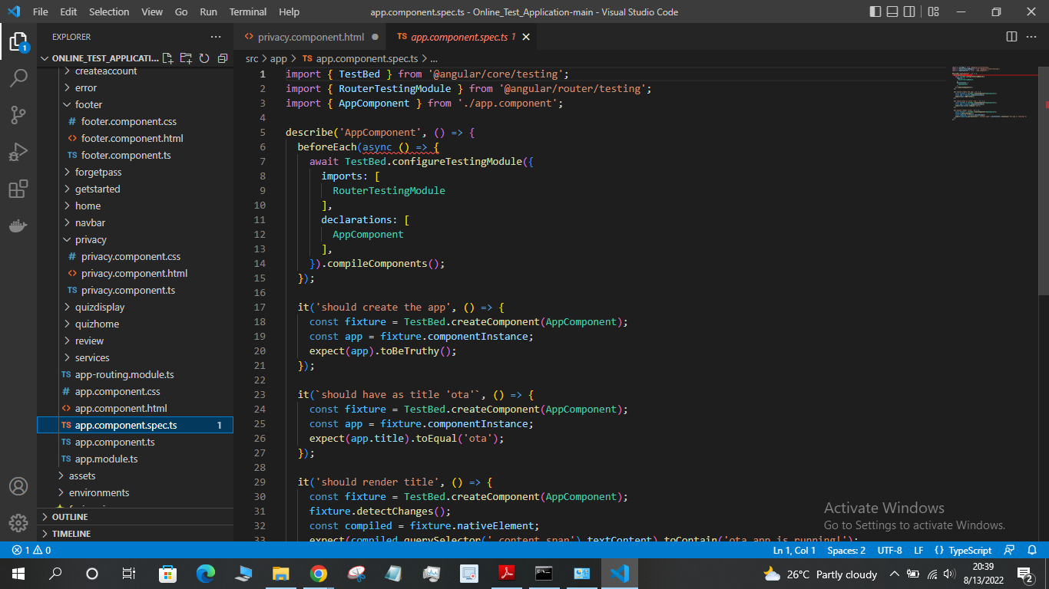

* 1. **Output Screenshots:**

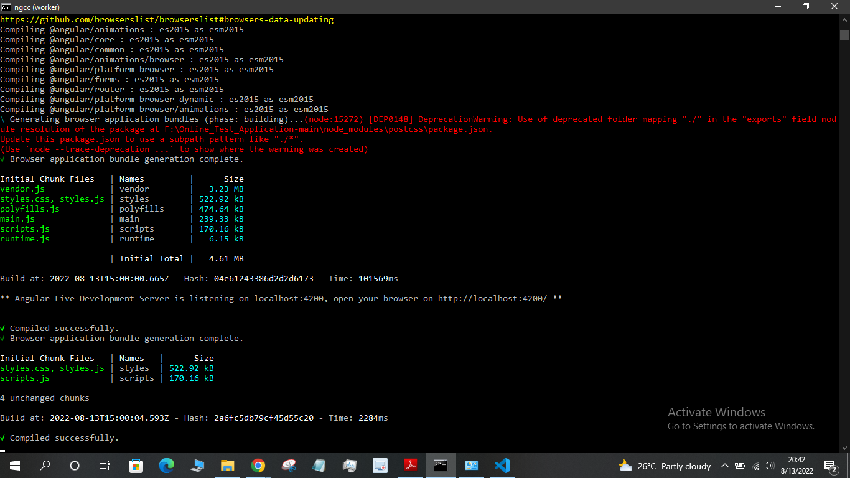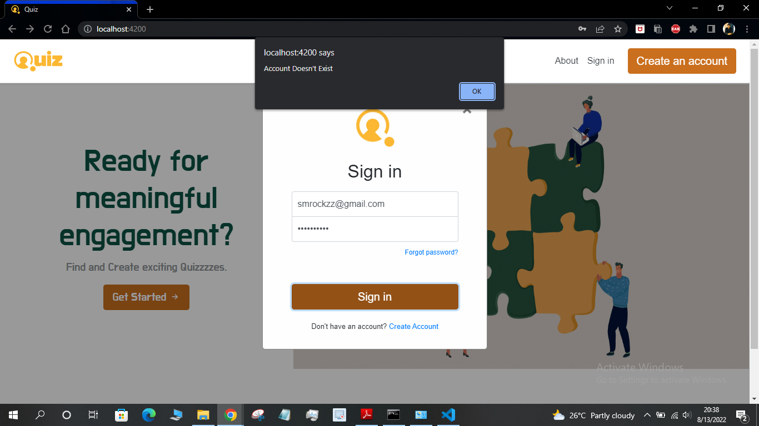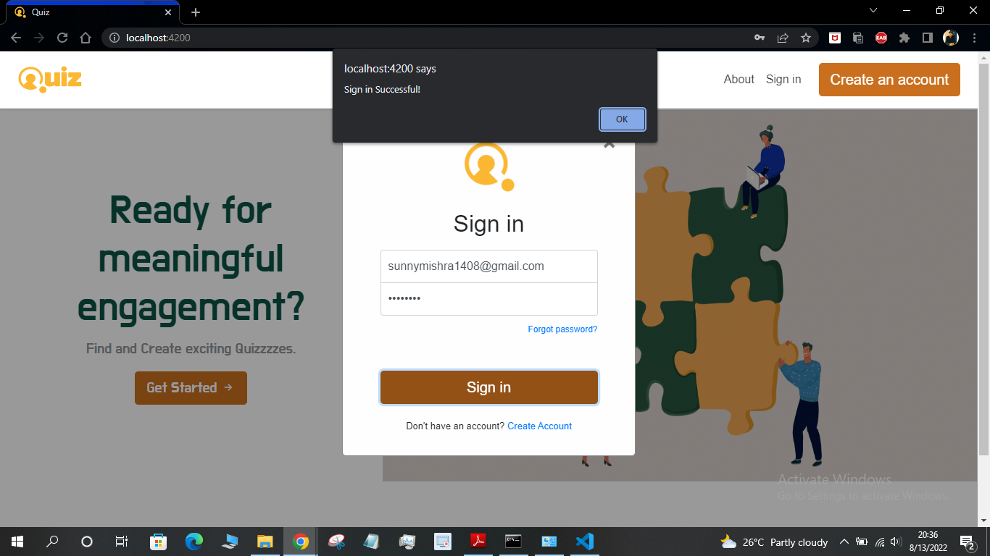

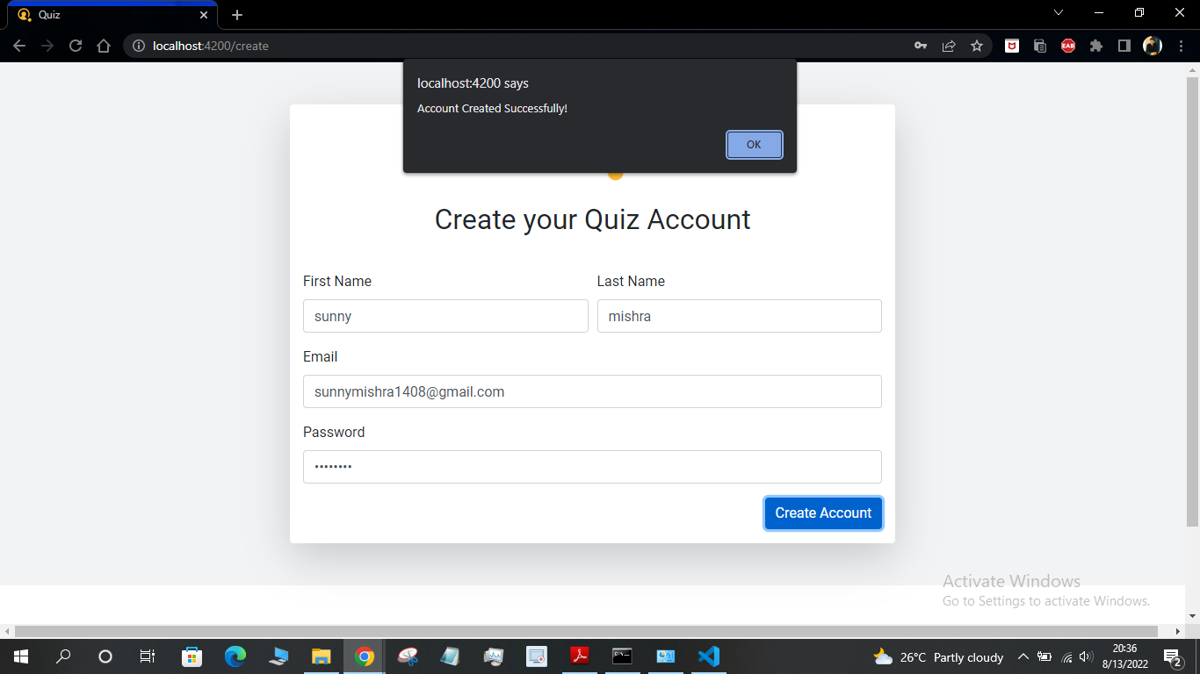

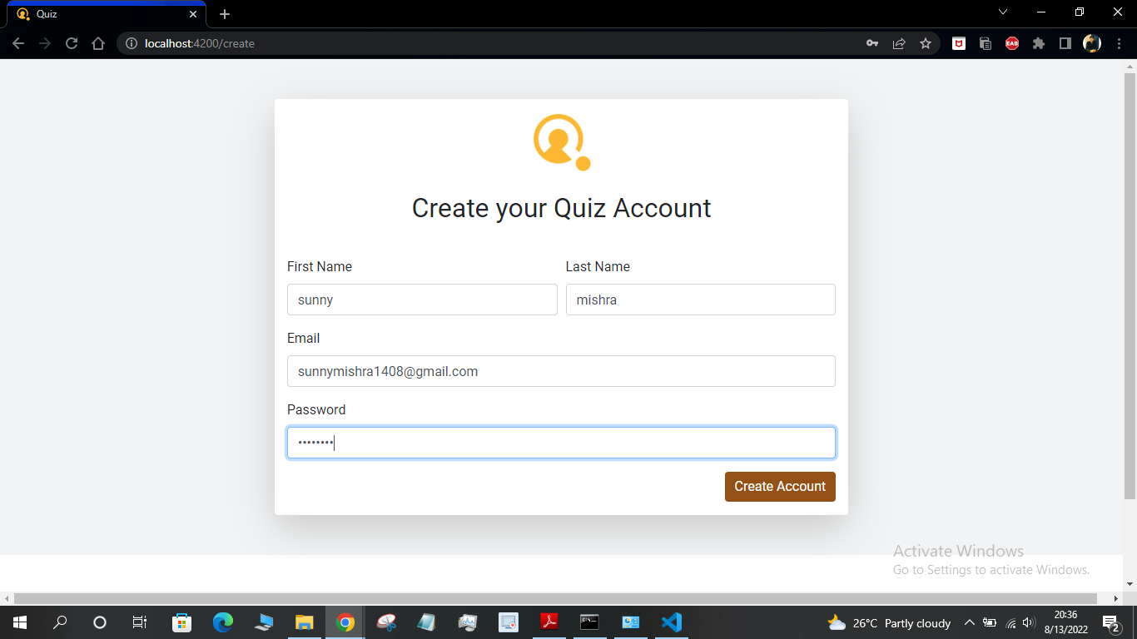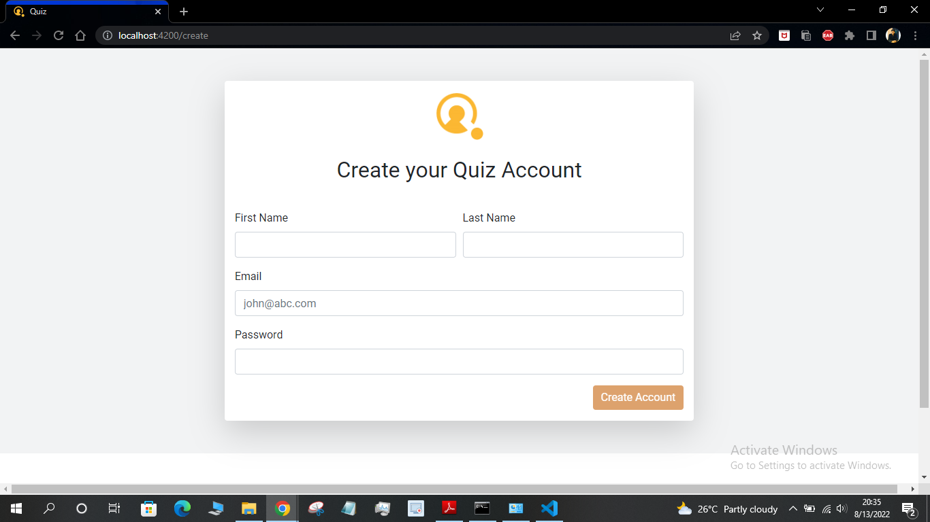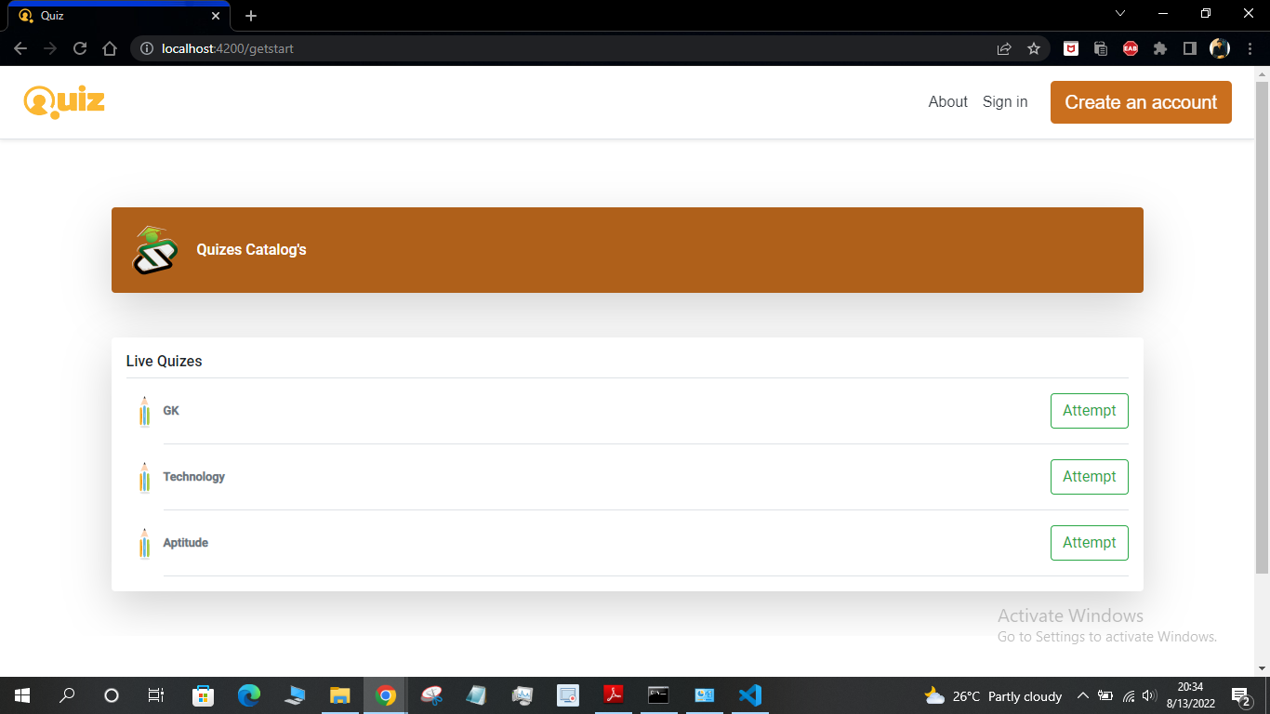

**4 Conclusion:**

The **Online Test Application** is user-friendly, very simple and convenient to use. The system is complete in that it is operational and under test

by entering the data and getting the reports in the correct order. But there is always room for improvement. During the development of this, coding standards are

followed for ease of maintenance and scalability. The project has been successfully designed and is tested for accuracy and quality. During this project, I achieved

all the goals and this project meets the needs of the assigned requirements.